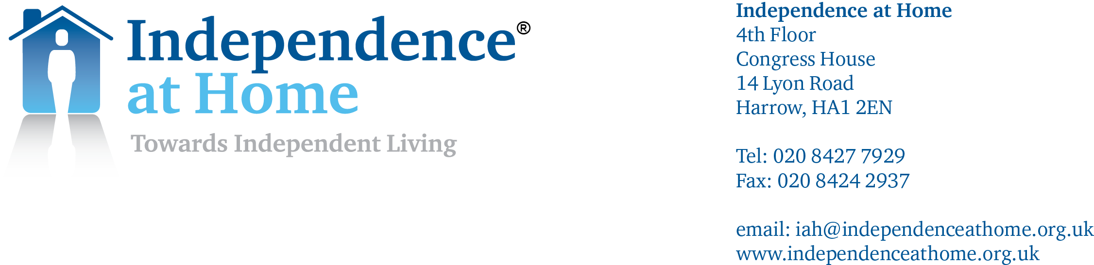

IAH CHARITY COMPANY LIMITED T/A INDEPENDENCE AT HOME
Registered Charity No: 1141758

Gift Aid Declaration

Your details (in capitals please):

Title ……… Forename (s)…………………………………………….......Surname...............………………………………………...

Home address ……….....................………………………………………………………………………………………………………......

…………………………………………………………………………………….....................Postcode............……………………………

I would like to make all my donations to Independence at Home under the Gift Aid scheme.
Accordingly, please treat all donations I have made for this tax year and the past four years, and any donations I make in the future, as Gift Aid donations. I am a UK taxpayer and understand that if I pay less Income Tax and/or Capital Gains Tax than the amount of Gift Aid claimed on all my donations in that tax year it is my responsibility to pay any difference,

Signed ………………………………………………………………... Date .......…………………………………………………..

Please notify Independence at Home if you:

1. Want to cancel this declaration
2. Change your name or home address
3. No longer pay sufficient tax on your income and/or capital gains.

Tax claimed by Independence at Home

. We will reclaim 25p on every £1 you give

If you pay Income Tax at the higher rate, you must include all your Gift Aid donations on your Self Assessment tax return or ask HM Revenue and Customs to adjust your tax code if you want to receive the additional tax relief due to you.

Please return this form, in the stamped addressed envelope provided, to:

Ms Katy Spooner, Chief Finance Officer, at the above address.

Thank you for your continued support of our work.

